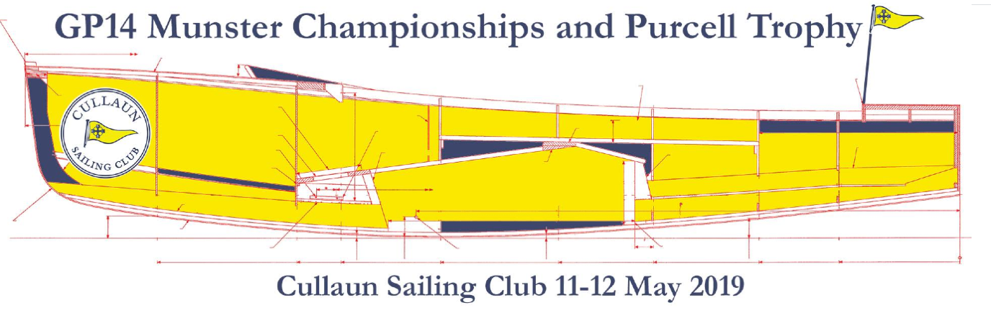

Location of Club Google Maps - https://goo.gl/maps/2obioENeeU5vcL5AA

GP14 Munster Championship & Purcell Trophy may 11th/12th 2019.

The GP14 Fleet from all provinces will battle it out for the Munster Championship & Purcell Trophy at Cullaun Sailing Club on May 11th & 12th 2019.

We would like to welcome the GP14 fleet to Cullaun Sailing Club for the first GP event ever to be held here, and the first one design fleet regatta to be held here in many years. The club was established in 1979 and celebrates its fortieth anniversary this year with the opening of its new clubhouse, which takes place this Saturday the 27th April.
Cullaun, which has been predominately Enterprises and Wayfarers for the last two decades, now has three GP14s competing weekly and hopes to build on this fleet over the coming years.
This is a small lake with tricky winds which should make for interesting racing
This event is a historic and exciting event for our club and we look forward to seeing you all at the GP14 Munsters in Cullaun Sailing Club, with hopefully good sailing weather and 2 days of exciting racing, BBQ, Music and more.

Location and accommodation.
The club lies between the villages of Kilkishen and Tulla in east Clare (25 minute drive from Limerick City, Shannon and Ennis) Although there is little accommodation available in Kilkishen there are beds available in a local hostel in Tulla (bredamoloneymac@gmail.com 087 8350996), some B@B and hotels within a twenty minute drive. There is camping available nearby to the clubhouse.

There will be a BBQ and music in the club on Saturday evening followed by drinks in the village.

With the event on in two weeks, the Club would appreciate if you can let them know of your intention to attend (and if you intend camping) by contacting Des MacMahon.
2desmac@gmail.com

http://www.cullaunsailingclub.com/
https://www.facebook.com/cullaunsailingclub
https://twitter.com/cullaunsailing
https://www.instagram.com/cullaunsailingclub/

