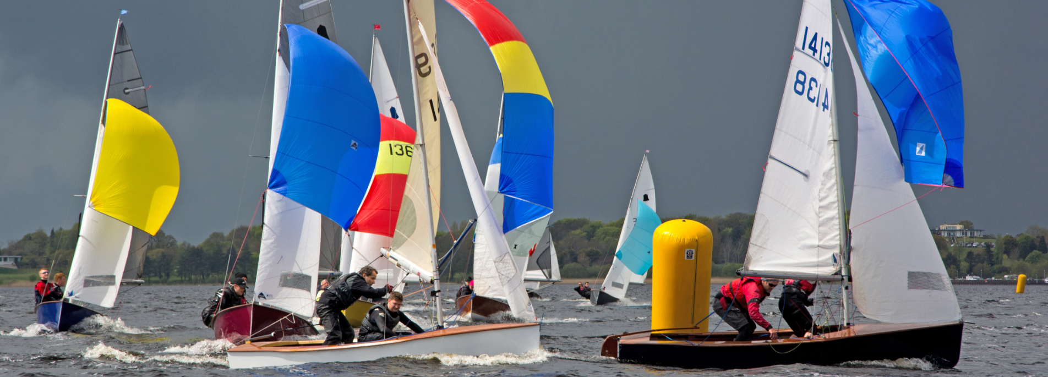

GP14 Irish Association - 2016 Events
Mar 26-Apr 4 | GP14 World Championship | Barbados
May 21/22 | O'Tiarnaigh Challenge & Purcell Trophy | Swords SBC
June 19/20 | Coleraine 24 hr Race | Coleraine YC
June 25/26 | Ulster Championship | East Down YC
July 23/24 | Leinster Championship & Mirror Irish Championship | Sutton DC
Aug 27/28/29 | Irish & Masters Championship | Skerries SC
Sept 24/25 | Autumn Open & Youth Championship | Sligo YC
Oct 15/16 | Hot Toddy | Blessington SC
For further info - www.gp14ireland.com

“GP 14 International Dinghy Helms & Crews”

