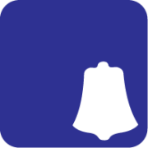
ENTRY FORM
THE G.P. FOURTEEN CLASS INTERNATIONAL ASSOCIATION
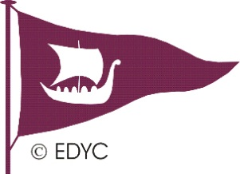
ULSTER CHAMPIONSHIP 2016
Organised by
East Down Yacht Club
25 th to 26 th June 2016

To: East Down Yacht Club - via Secretary Alan Wood, I Pirrie Lane, Belfast BT 4 3NP.

Please enter GP14 Boat No. | Boat Name
Please indicate Gold/Silver or Bronze fleet
Helm. First & Surname |  | Date of Birth
Address:
 | Post Code
e-mail | Tel No
Club
Crew First & Surname |  | Date of Birth
Address
 | Post Code
e-mail | Tel No.
Club

Number in Party | Adults | 12-18 yrs | 6-11 yrs | 0-5 yrs

I enclose fees as below, to be received by one of the dates below (Please Tick box)
Either £40 by 19th June 2016
OR I am paying the late fee of £45 (after 19th June 2016)

Accomodation on site | No of nights | Total £
Camping - tent nights at £5
Motor Home nights at £10

Entrants enjoy temporary membership of East Down Yacht Club during the event.

I agree to be bound by the Racing Rules of Sailing, the rules of the GP. Fourteen Class International Association, the sailing Instructions and any amendments thereto.

I certify that I am a paid up member of The G.P. Fourteen Class International Association.
I agree to produce the boat’s valid class Certificate before the first race.
I certify that the boat is insured for a minimum of £3,000,000 Third Party/Public Liability Cover.

Signed | Date

Please draw cheques in favour of the East Down Yacht Club.

World Wide Web
Competition details, photos and results will be available on the World Wide Web.
I agree for our details of Sail number, Competitor name, Crew name and Sailing club to be included on the web site listings. (delete if required)
The Information Requested below to assist vehicle control
Helm’s Vehicle Reg. |  | Crew’s Vehicle Reg.
Helm’s Mobile Tel No |  | Crew’s Mobile Tel No

Site usage information
Caravan or motorhome sites are very limited and must be booked and confirmed as early as possible, allocated on a first request received basis – tent camping will be more relaxed however we ask you to consult the club before pitching your tent or parking your motor home.
All sites are not serviced.
Social and catering information
You are welcome to arrive on the Friday night 24th June
Holm Bay Bar will be open from19:00 to 22:30 Fri 24th June
A mid- summer Bar-b-cue will be from 18:30 on Sat 25th June - meat options and packs on sale
Entertainment - The Folkin Eejits in the Holm Bay Bar Saturday night
Cooked breakfasts from 08:30 to 10:00 on Sunday 26th June

