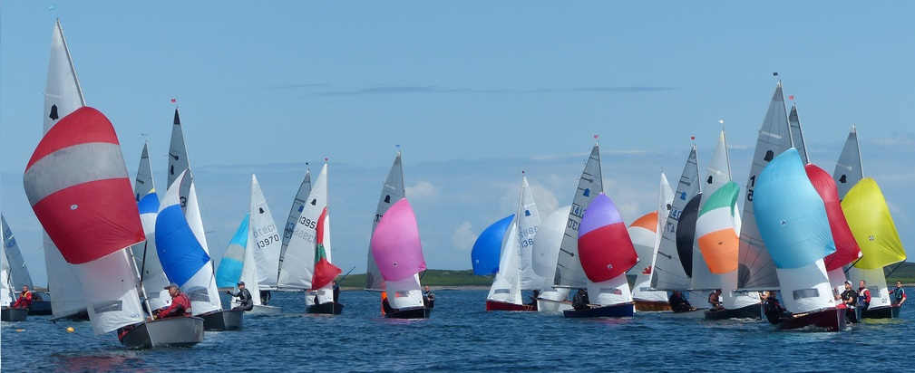

GP14 Irish Association - 2015 Events
Sat 18 - Sun 19 | Apr | O’Tiarnaigh Challenge | Swords Sailing Club
Sat 2 - Sun 3 | May | Purcell Trophy* | Lough Ree Yacht Club
Sat 13 - Sun 14 | Jun | Ulster Championships | Lough Erne Yacht Club
Fri 10 - Sun 12 | Jul | Leinster Championships | Dun Laoghaire
Sat 29 - Mon 31 | Aug | Championship of Ireland | Newtownards Sailing Club
Sat 26 - Sun 27 | Sep | Youth & Autumn Open | Greystones Sailing Club
Sat 17 - Sun 18 | Oct | Hot Toddy | Mullingar Sailing Club
*Purcell Trophy will be a combined event with the Mirror fleet.
For further info - www.gp14ireland.com

“GP 14 International Dinghy Helms & Crews”

